**Task 1: Launch the Apache2 Container**

1. **Run the Apache2 Container:**

**docker run -d --name apache2-container -p 80:80 shahid199578/my-ubuntu-apache-image apache2ctl -D FOREGROUND**



* + -d: Runs the container in detached mode.
  + --name apache2-container: Names the container apache2-container.
  + -p 80:80: Maps the container's port 80 to the host's port 80.
  + apache2-image: The name of the Apache2 Docker

1. **Verify the Container is Running:**

You can check the running containers with the command:

**docker ps**

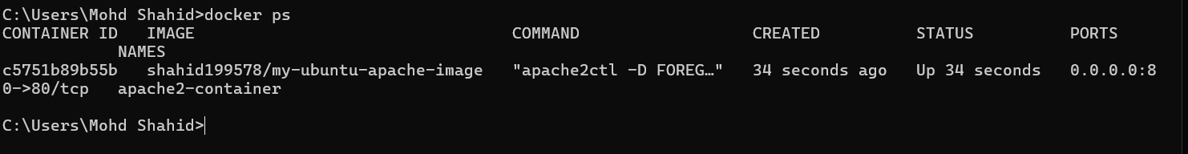

**Task 2: Create a Docker Volume on /var/www/html**

Docker volumes are used to persist data between container restarts. To create a Docker volume and mount it to the /var/www/html directory inside the Apache2 container:

1. **Create the Volume:**

**docker volume create apache2-html**



1. **Launch the Container with the Volume:**

Now, launch or recreate the Apache2 container with the volume mounted to /var/www/html:

**docker run -d --name apache2-container-volume -p 82:80 -v apache2-html:/var/www/html shahid199578/my-ubuntu-apache-image apache2ctl -D FOREGROUND**



-v apache2-html:/var/www/html: Mounts the volume apache2-html to the /var/www/html directory inside the container.

1. **Verify Volume is Mounted:**

inspect the container to verify the volume is properly mounted:

**docker inspect apache2-container**

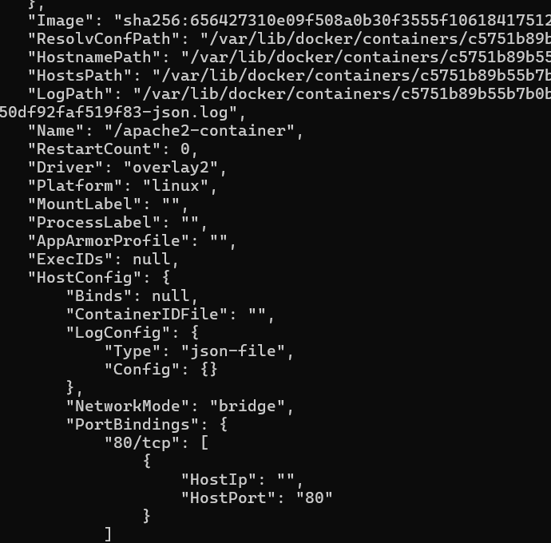

**docker inspect apache2-container-volume**

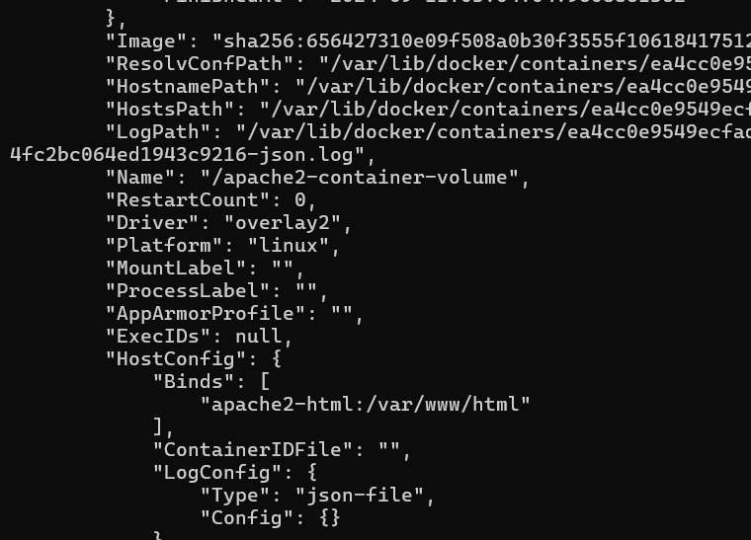

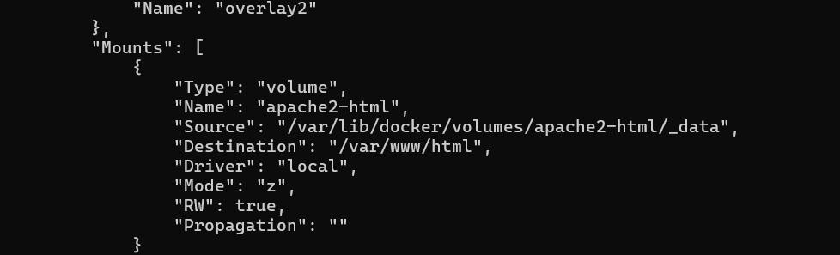

Check the "Mounts" section to ensure that apache2-html is mounted to /var/www/html.

This will ensure that any data in /var/www/html persists even if the container is restarted.